1. A novel approach for the quantification of different inorganic and
2. organic phosphorus compounds in environmental samples by P
3. L2,3-edge XANES spectroscopy
4. *Luis Carlos Colocho Hurtarte,†* Helen Carla Santana Amorim,‡ Jens Kruse,§ Julio Criginski*
5. *Cezar,∥ Wantana Klysubun,§§ Jörg Prietzel†*

6

1. †Lehrstuhl für Bodenkunde, Research Department Ecology and Ecosystem Management,
2. Technische Universität München, Emil-Ramann-Straße 2, 85354 Freising, Germany
3. ‡Universidade Federal de Lavras, Departamento de Ciência do Solo, 1001 Av. Doutor Silvio
4. Menicucci, Lavras, MG 37200-000, Brazil;
5. §Institute of Bio- and Geosciences, Agrosphere Institute (IBG-3), Forschungszentrum Jülich
6. GmbH, Wilhelm Johnen Straße, 52425 Jülich, Germany
7. 1Institute of Crop Science and Resource Conservation (INRES), Soil Science and Soil Ecology,
8. University Bonn, Nussallee 13, 53115 Bonn, Germany
9. ∥Laboratório Nacional de Luz Síncrotron – Centro Nacional de Pesquisa em Energia
10. eMateriais,13083-970 Campinas, SP, Brazil
11. §§Synchrotron Light Research Institute, Muang District, 111 University Avenue, Nakhon
12. Ratchasima 30000, Thailand

# ABSTRACT

1. Phosphorus (P) is an essential element for life on Earth, with an important and oftentimes
2. unaccounted organic biogeochemical component. Current methods for the quantification of
3. different organic P compounds in environmental samples (e.g. soils, sediments) are based on
4. extraction techniques and often associated with incomplete P recovery or sample changes. In this
5. study, we present a protocol for the quantification of different organic and inorganic P species in
6. soils using synchrotron-based XANES spectroscopy at the P L2,3-edge. Its accuracy and precision
7. was evaluated by analyzing 40 standard mixtures composed of seven different inorganic and
8. organic P compounds (mean R2 = 0.85). Additionally, we quantified the P species of two soils and
9. two agro-industrial byproducts using P L2,3-edge XANES spectroscopy and the results were
10. compared with those obtained by P K-edge XANES or 31P NMR spectroscopy. Using the P L2,3-
11. edge we identified different organic species, including those not identified by the common P K-
12. edge XANES. However, there is a consistent underestimation of organic polyphosphates. Overall
13. the application of P L2,3-edge XANES provides a higher level of information than by P K-edge
14. XANES, although the ubiquitous use of this novel methodology is still limited to samples with
15. phosphorus content above 3 mg g-1.

35

36 KEYWORDS: soil P speciation, P K-edge XANES, 31P-NMR spectroscopy 37

38 Graphical Abstract 39

# 1. Introduction

1. Life on earth would not be possible without phosphorus (P); as it is present in various
2. biomolecules, whose functions range from energy transport to serving as structural component in
3. cellular walls and nucleic acids.1 Primary productivity in many terrestrial and aquatic ecosystems
4. is maintained by the input of P derived from bedrock weathering, dust deposition, and recycling
5. of internal system P 2–4, with organic P forms comprising up to 90% of total soil P.5 Speciation of
6. organic P in soils and sediments most often relays on results of liquid 31P nuclear magnetic
7. resonance (NMR) spectroscopy 6–10 with phosphate monoesters, phosphate diesters, and organic
8. polyphosphates 11,12 as the most dominant P forms. However, liquid 31P NMR spectroscopy
9. requires a preceding extraction step using a mixture of ethylenediaminetetraacetate (EDTA) and
10. NaOH 13,14. This leads to two fundamental problems i) an often incomplete extraction 15 and ii)
11. extraction-induced changes in the sample composition – in the case of liquid 31P NMR the
12. hydrolysis of organic P compounds. 6 Thus, liquid 31P NMR spectroscopy results are influenced
13. by the sample pre-treatment, which all together can jeopardize ecological interpretation. This calls
14. for alternative analytical methods to characterise organic P forms in soils and sediments without
15. harsh sample pre-treatment.
16. X-ray absorption near-edge structure (XANES) spectroscopy may offer a possibility to
17. overcome these limitations as it requires no preceding extraction and only minimal sample
18. preparation.16 Due to the increased accessibility to high-brightness synchrotron beamlines,
19. application of XANES spectroscopy has become increasingly relevant in soil P research during
20. the last two decades.17–23 Thereby, most P XANES studies have been focused on the K-edge
21. (~2150 eV) where the P 1s→3p transition is probed. However, when probing the K-edge, the
22. speciation of organic P forms is difficult or even impossible due to the lack of distinguishable
23. spectral features among different organic reference compounds at the P K-edge.24,25 By contrast,
24. P XANES spectroscopy at the L2,3-edge seems to be more promising because the L2,3-edge spectra
25. of different organic and inorganic P forms are characterised by more potentially distinguishable
26. spectral features.26 Although investigations using P L2,3-edge XANES spectroscopy have been
27. carried out, it has been mainly in the field of field of material science27,28,37,38,29–36 and only a few
28. were dedicated to environmental related samples.19,32,39 The latter can be explained by the high P
29. concentration (>3 mg g-1) required to record of P L2,3-edge compared to the P K-edge (0.1 mg g-1)
30. spectra due to lower excitations probabilities at lower excitation energies.40 Furthermore, spectral
31. data evaluation was so far mainly restricted to visual comparisons with reference compounds
32. instead of quantitative data evaluation by e.g., linear combination fitting (LCF) as often used in P
33. K-edge XANES data evaluation.41–43 This is mostly due to difficulties in spectral data treatment,
34. namely regarding a correct deconvolution of an oftentimes non-linear background originating from
35. excitations of other matrix elements, low-energy electrons, and sample charging which
36. complicates the spectrum normalization and thus subsequent fitting of spectra. Adding to this, the
37. detection of secondary emissions (fluorescence and electron yield) which originate from the
38. relaxation processes upon x-ray absorption are prone to distortions (saturation and self-
39. absorption)44 yet unaccounted on past studies of the P L-edge. These problems are even more
40. challenging in spectra from soils or sediments characterised by high silicon (Si) contents usually
41. exceeding those of P. This Si - mostly present in quartz and/or clay minerals- can distort P L2,3-
42. edge XANES spectra, due to spectral overlap with Si L-edges at energies below (L3-edge: 99.2
43. eV; L2-edge: 99.8 eV) and above (L1-edge: 149 eV) the energy of the P L2,3-edge36,45–47 (see Figure
44. S1 Supplementary information), which has been shown in several studies on material
45. science.31,36,46 Yet, to the best of our knowledge, no study in environmental sciences so far has
46. addressed or even acknowledged this problem.
47. Therefore, the aim of this study was (i) to develop a spectral data workflow for a consistent data
48. treatment which enables a quantitative data evaluation via LCF, and subsequently (ii) to evaluate
49. the capabilities and uncertainties of synchrotron-based P L2,3-edge XANES spectroscopy for the
50. identification and quantification of different organic and inorganic P compounds in soils and other
51. environmental samples. For this, we used 40 artificial mixtures of P reference compounds with
52. known composition and two soils and two agro-industrial byproducts. For the latter, P speciation
53. results obtained by P L2,3-edge XANES spectroscopy were compared with those obtained for the
54. same samples by P K-edge XANES (soils) or 31P NMR spectroscopy (agro-industrial byproducts).

# 2. Materials and Methods

1. 2.1 P Standards and defined artificial mixtures
2. We used four standards representing major organic P species and three reference standards
3. representing different inorganic P species in soils which are summarized in Table 1. We diluted
4. each reference standard with fine-ground (mesh 230), high-purity quartz *“purum” (*Sigma-
5. Aldrich: CAS: 14808-60-7) to a final concentration of 40 mg P g-1 using an agate mortar and pestle.
6. Total P concentrations in all diluted reference standards were checked for correctness by digestion
7. of each diluted standard with hydrofluoric acid (HF) and perchloric acid (HClO4) and subsequent
8. element analysis using inductively coupled plasma optical emission spectrometry (ICP-OES;
9. Vista-PRO Simultaneous ICP-OES, Varian Inc., Palo Alto, CA, USA) (Data not shown).
10. We produced three sets of defined artificial ternary and quaternary mixtures by weighing
11. different amounts of the seven diluted reference standards in various combinations to 1 g of
12. sample, and homogenising them manually with agate mortar and pestle.
13. These quartz diluted artificial mixtures were prepared to both mimic typical soil matrices by
14. introducing a signal distortion caused by the excitation of the Si L-edges and represent a broad
15. concentration range of either (i) three organic P compounds and one inorganic P form (Set A:
16. inorganic P as hydroxyapatite, P monoesters as phytic acid, P diesters as deoxyribonucleic acid
17. sodium salt, and phosphonates as methylphosphonic acid), (ii) three inorganic P compounds and
18. one organic P form (Set B: hydroxyapatite, iron(III) phosphate, aluminium phosphate, and phytic
19. acid as an organic phosphate), or (iii) four organic P compounds (Set C: P monoesters as phytic
20. acid, P diesters as deoxyribonucleic acid sodium salt, phosphonates as methylphosphonic acid, and
21. adenosine 5’-triphosphate as polyphosphate). We proceeded in this way to validate the robustness
22. of the P L2,3-edge XANES spectrum deconvolution method for a broad range of P species
23. proportions. In total, 40 diluted ternary and quaternary mixtures of the standards were produced
24. (Tables S2, S3, and S4).
25. 2.2 Exemplary soil samples
26. In order to test the feasibility of our approach for important environmental questions, we also
27. analysed two P-rich soils from a penguin colony site located on Deception Island (South Shetland
28. Islands, Maritime Antarctica). Soil samples were taken on a site with an active moss layer (P04)
29. and on another site with a dead moss layer (P16). The soil samples were finely ground using an
30. agate mortar and pestle. A chemical characterization of the two soil samples is given in Table S5.
31. 2.3 P L2,3-edge XANES spectroscopy
32. Phosphorus L2,3-edge XANES spectra of diluted reference standards, standard mixtures, and
33. soil samples were acquired at the Brazilian Synchrotron Light Source (LNLS) at the Planar Grating
34. Monochromator (PGM) beamline. Finely ground sample powder (~230 mesh) was spread as a thin
35. film onto a double-sided P-free carbon tape “Spectro-tabs” (G3358, Plano GmbH, D-35578
36. Wetzlar, Germany). The PGM´s beam source is an elliptical polarization undulator with a 50 mm
37. period (EPU50). Its optics are based on a standard grating monochromator (PGM) equipped with
38. a 1500 l/mm variable line spacing (VLS) diffraction grating.48 Spectra acquisition was performed
39. by recording the X-ray absorption in total electron yield (TEY) between 130 eV and 160 eV, with
40. a step size of 0.1 eV and a dwell time of 1 s. TEY was measured with an amperemeter. Recorded
41. spectra were normalized to the incident beam intensity (I0), which was simultaneously recorded as
42. the absorption from a gold mesh upstream the beamline. A total of three to four scans were
43. averaged to yield a good signal-to-noise ratio for each sample spectrum. Additionally, to analyse
44. possible contributions of the Si L-edges on the P L2,3-edge XANES spectra, we recorded a
45. spectrum of the pure quartz and of the phytic acid diluted with quartz to 40 mg P g-1 in the energy
46. range from 90 to 160 eV.
47. 2.4 Spectrum processing and fitting
48. The XANES data was initially pre-processed using the ATHENA program of the software
49. package DEMETER.49 Individual scans were examined for glitches, drifts, noise, and general
50. quality before merging them. Subsequently, the zero crossing of the second derivative of the
51. absorption were used to determine E0 values of the merged spectra. The calibrated data were
52. further processed using the *LCF* package of the R software (Version 3.3.2).50
53. To account for the nonlinear background, merged spectra were background corrected, using a
54. grade-two polynomial function between four points across the pre-edge and post-edge regions (E0-
55. relative values: -3 eV, -1.5 eV, +19.0 eV, +21.5 eV). Thereafter, each baseline-corrected spectrum
56. was normalized to the highest intensity point across the spectrum.51 Optimization of background
57. subtraction was performed by generating a matrix of different background values, similar to a
58. procedure developed earlier for the deconvolution of P K-edge XANES spectra of soil samples50
59. (pre-edge value 1 from -4 eV to -2.5 eV; pre-edge value 2 from -2 eV to -0.5 eV; post-edge value
60. 1 from +16 eV to +17.5 eV; post-edge value 2 from 19.5 eV to 22 eV; all with a step of 0.1 eV).
61. The LC fitting was performed from -3eV to 16 eV (relative to E0) using the *fit_float* function of
62. the *LCF* package. Combination of all baseline-corrected spectra resulted in >100,000 spectra
63. variants and LC fits for each sample. The fittings were ranked by their R-factors (X2 divided by
64. the sum of the squared sample data), and the one presenting the lowest R factor was chosen as
65. final fitting result. This approach guarantees that all possible background subtraction possibilities,
66. within the range given, are tested for the LC fitting. Linear regression and Pearson’s correlation
67. coefficients between determined and expected proportions of different P species in the various
68. standard mixtures were calculated using R. The deviation from the true contribution was calculated
69. as the difference between the XANES LC fitting results and the true species contribution to the
70. total P.
71. 2.5 Re-analysis of older P L2,3-edge XANES spectra obtained for agricultural by-products
72. Additionally, we applied the designed P L2,3-edge XANES spectra analysis workflow to an
73. additional P L2,3-edge XANES spectra dataset obtained for two agricultural by-product samples at
74. the VGM beamline of the Canadian Light Source (CLS; Saskatoon, Canada) by Negassa et al.52,
75. namely a sugar-cane filter cake (FIC) and a niger seed filter cake (NIC). Detailed information on
76. these samples is presented in ref. 36 and in Table S6. We performed the LC fitting according to
77. the protocol described above and compared the P speciation results obtained by P L2,3-edge
78. XANES with those obtained for the respective samples by 31P-NMR spectroscopy by Negassa et

174 al.52

# 3. Results and Discussion

1. 3.1 Background subtraction function and quantification of P compounds in defined mixtures
2. Baseline correction was the most fundamental part of the analysis, and to the best of our
3. knowledge, the confounding effect of Si on the shape of P L2,3-edge XANES spectra has been
4. overlooked in previous studies where both elements are present.31,37 In this study, we confirm that
5. Si can cause distortion of P L2,3-edge XANES spectrum if significant proportions of Si a present
6. in the sample due to the proximity of both edges (Figure S1). Moreover, comparing the spectrum
7. of phytic acid and phytic acid diluted in quartz reveals that the non-linear background of the diluted
8. phytic acid P L2,3-edge XANES spectrum is at least partly caused by interference of the Si L-edges
9. (Figure S1). The presented approach, using a four-point background subtraction, allowes the
10. subtraction most of the background Si and charging effects from the sample spectra, and thus
11. minimize impacts of spectral distortions on the fitting results. Moreover, the use of the LCF
12. package allows the calculation of concise results, as it allows the quick test of all possible
13. background combination possibilities.53
14. LC fitting results yielded R-factors <0.01 in all mixtures (Tables S2, S3, S4), indicating that the
15. models have good agreement with the sample spectra. Correlation analysis and linear regressions
16. of fitting results *vs.* expected proportions of different P standards in the 40 mixtures yielded
17. correlation coefficients >0.8, *p*-values <0.00001, intercept values close to 0 and slope values close
18. to 1, respectively (Figure 2). Overall, in the fits the contribution of organic P species to total P was
19. slightly underestimated by L2,3-edge XANES spectroscopy (mean absolute difference of
20. determined *vs.* true species contribution to total P for phosphate diesters: 11±7%; for phosphate
21. monoesters: 8±6%; for organic polyphosphates: 14±9%; for phosphonates: 7±7%). In contrast, the
22. contribution of inorganic P species was slightly overestimated (mean absolute ratio of determined
23. *vs.* true species contribution to total P for Al-P: 8±5%; Fe-P: 10±6%; Ca-P: 4±3%). These numbers
24. demonstrate a high accuracy and precision of the method when all P-bearing constituents of a
25. sample are known, but not their proportions. We are aware that this is a best-case scenario and
26. accuracy and precision can be lower when constituents are not exactly known and have to be
27. chosen based on e.g., ancillary data about the sample of unknown composition.
28. The potential advantages of using the P L2,3-edge for the identification of organic P or Ca-bound
29. P forms have been mentioned repeatedly in earlier studies;26,39,40,54 however, to the best of our
30. knowledge none of these studies used LC fitting to also obtain quantitative information.
31. Therefore, we are the first to show that diluted mixtures with known organic P species (i.e.,
32. phosphonates, phosphate monoesters/diesters, and organic polyphosphates) can be speciated using
33. P L2,3-edge XANES with good accuracy and precision after appropriate data processing.
34. Moreover, these results show that the speciation of inorganic phosphates (Fe-P, Al-P, Ca-P) is
35. possible with even higher accuracy than with P K-edge XANES spectroscopy.50 Although our
36. study shows that the speciation of organic P species has a higher variance than when studying
37. inorganic P species, it must be highlighted that this higher variance because the subtler feature
38. differences between the different organic species. This is very understandable since the nearest
39. neighbouring atom of all is C, and thus provides similar electron affinity.
40. The presented approach using an empirical background subtraction procedure yielded similar
41. spectra to those presented in other studies measuring in transmission (no charging effects)55 and
42. without Si.56 We confirmed this by measuring spectra for diluted and undiluted standards of
43. hydroxyapatite (Figure S2), thus it effectively removes most Si artefacts introduced in a Si
44. dominated. However, other empirical approaches yet to be tested using more complex background
45. subtraction methods could provide even more flexible and smoother background subtraction.
46. 3.2 Method validation using environmental samples: Comparison with K-edge XANES and 31P-
47. NMR spectroscopy
48. To compare our speciation procedure and its applicability to complex materials found in
49. natural environments, we compared the P speciation in soil samples and agro-industry by-products
50. using P L2,3-edge XANES spectroscopy with those obtained by P K-edge XANES at beamline 8
51. of the Synchrotron Light Research Institute (SLRI), Nakhon Ratchasima, Thailand57,58, using the
52. procedure and standards described previously20,59 (soil samples) or by 31P-NMR spectroscopy19,60
53. (agro-industrial by-products). For the two ornithogenic soil samples, P K-edge XANES
54. spectroscopy revealed a very similar P speciation with most P in inorganic forms such as Fe-bound
55. phosphate (P04: 50% of total P; P16: 44%) and as Al-bound phosphate (P04: 37% of total P, P16:
56. 45%) (Table 1). This is in agreement with previous studies on P speciation of ornithogenic soils in
57. Antarctica, using other techniques such as XRD, which reported that much of the penguin guano
58. is mineralized to form phosphate minerals such as variscite and vivianite at low pH.61,62
59. Results obtained by P L2,3-edge XANES spectroscopy agree very well with those obtained by
60. P K-edge XANES spectroscopy (Table 1). However, by using P L2,3-edge XANES we were able
61. to differentiate even between diester phosphates and monoester phosphates which was not possible
62. at the P K-edge (after applying the same set of standards). We also contest to another study where
63. the molecular transformations of guano in soils were investigated using 31P-NMR spectroscopy.63
64. They describe guano-derived soils as particularly rich in orthophosphate, followed by monoester
65. and diester phosphates. However, results show a contrasting trend of higher diester phosphates,
66. followed by monoester phosphates. This might be explained by the partial hydrolyse of diester
67. phosphates during extraction with NaOH-EDTA leading to a underestimation of diester
68. phosphates in these soils by 31P-NMR spectroscopy64. Moreover, phosphate diester accumulation
69. would be expected in soils undergoing mineralization.62. This again demonstrates the advantage
70. of the P L2,3-edge XANES spectroscopy, as it was able to discriminate between mono- and diester
71. phosphates, without a need of an extraction step and thus to specifically quantify a P compound
72. (diester phosphates) with high ecological relevance in organic P rich soils such as in e.g.,
73. ornithogenic soils.
74. The analysis of the agro-industrial by-products by 31P-NMR spectroscopy showed that both
75. samples differed strongly in their P speciation. The sugar-cane filter cake (FIC) has 94% of its
76. total P as orthophosphate, and 6% as phosphate monoesters; while for the niger seed filter cake
77. (NIC), only 6% of total P was orthophosphate, and 94% was phosphate monoesters (Table 1).
78. Thus, the two samples were excellent endmembers to test the P L2,3-edge XANES-based P
79. speciation method. Moreover, the high extraction efficiency of NaOH/EDTA for both samples
80. (FIC: 94% and NIC: 83% of total P) allowed us to directly compare the P speciation results
81. obtained for the agro-industrial by-products by P L2,3-edge spectroscopy in this study with the
82. respective P speciation results obtained earlier17 on their NaOH/EDTA extracts by 31P-NMR
83. spectroscopy.
84. The real power of using the P L2,3-edge XANES spectroscopy can only be acknowledged when
85. reviewing the distribution of the individual organic P species (Table 1). Whereas P K-edge
86. XANES spectroscopy and 31P NMR only identify one species (phosphate monoesters), the P L2,3-
87. edge XANES spectroscopy discriminates other organic species. This capability to distinguish
88. different organic P species without previous sample preparation coupled to the at sub-micron
89. spatial resolution when using STXM, is unique to the P L2,3-edge and could shed light to currently
90. unknown P and C association mechanisms to mineral phases. Moreover, considering that in the
91. soil samples the P concentration was lower than the in agro-industrial by-products, and spectral
92. interference of the Si L-edge was present for the soil samples, the results demonstrate the ability
93. of the proposed workflow to minimize the influence of Si and other artefacts by optimizing
94. background values and using other background functions.
95. 3.3 Potential applications: Soils, biominerals, and rock surfaces
96. We evaluated the applicability of synchrotron-based P L2,3-edge XANES spectroscopy for the
97. quantification of organic and inorganic P in soils and environmental samples. The spectrum
98. processing workflow here presented permits an accurate and precise quantification of major
99. organic P species present in the environment. XANES LC fitting results at any edge of any
100. element, depend on the standards used and assume a linear relation between the proportion of each
101. component and its influence in the spectral features. Thus, complementary analyses that suggest
102. which standards can be used for the LC fitting exercise will benefit the analysis. Common analyses
103. could be EDX/XRF analyses23, Raman spectroscopy 65, among others, coupled to data reduction
104. procedures to the XANES spectrum(i.e. principal component analysis followed by target
105. transform)66. A lternative approaches for XANES speciation would be the use of predictive
106. regression models (random forests, partial-least squares, neural networks), which show great
107. predictive capabilities,67,68 and should be further studied. Yet, the need of a large number of
108. independent samples for them to be trained hampers their use.
109. Similar to other recent studies using P L2,3-edge XANES spectroscopy for the P speciation of
110. environmental samples54,69 or biominerals,32,55,70 the samples used in this study had P
111. concentrations of ~4 mg g-1, which is larger than those present in many soils and sediments. At
112. present, a reliable, accurate, and precise P speciation using L-edge XANES spectroscopy is
113. impossible for environmental samples with P concentrations <3 mg g-1 without prior either P-
114. enriching sample pre-treatment (*e.g.,* isolation of clay fraction; SOM extraction, diffusive
115. gradients in thin films)69 or analysis of P hotspots (*e.g.,* by µ-L-edge XANES).55 However, several
116. alternatives to probe the P L-edge arise with the ongoing rapid advance in synchrotron technology.
117. Under increased photon flux71–74, the use of resonant x-ray absorption (XANES) or emission (e.g.,
118. nonresonant raman x-ray scattering) techniques75 coupled to energy discriminant detectors,76 will
119. likely allow an accurate and precise P speciation on soil samples with low (< 3 mg g-1) P
120. concentration by L2,3-edge XANES spectroscopy in the near future.
121. **Table 1:** Reference compounds used for the ternary and quaternary mixtures.

P form Compound Group

Inorganic Iron (III) phosphate Iron phosphate Hydroxyapatite Calcium phosphate

Aluminium phosphate Aluminium phosphate

Organic Phytic acid sodium salt hydrate Monoester phosphate Deoxyribonucleic acid sodium salt Diester phosphate Methylphosphonic acid Phosphonate

Adenosine 5’-triphosphate disodium salt hydrate

Organic polyphosphate

1. **Table 2:** P speciation results obtained for two soils from a penguin rooker on Deception Island, Maritime Antarctica (P04, P16) and two
2. agro-industrial by-products (sugar cane filter cake [FIC], niger seed filter cake [NIC]) by P L2,3-edge XANES spectroscopy compared
3. to P speciation results obtained by P K-edge XANES (soils) or liquid 31P NMR spectroscopy (agro-industrial by-products). ND: Not
4. determined. IHP: Inositol phosphate.

Contribution to total P (%)

Organic P

Fe-bound P Al-bound P Orthophosphate P IHP P-diester

*Soils*

P04 L2,3-edge XANES 51±6 33±5 ND 7±6 9±6

K-edge XANES 50±7 37±4 ND 13±9 0

P16 L2,3-edge XANES 48±6 34±5 ND 6±6 10±6

K-edge XANES 44±7 45±4 ND 11±9

*Agro-industrial by-products*

FIC L2,3-edge XANES 0 0 92±4 8±6 0

31P NMR spectroscopy 0 0 94 6 0

NIC L2,3-edge XANES 0 0 5±4 95±6 ?

31P NMR spectroscopy 0 0 6 94 0

1. 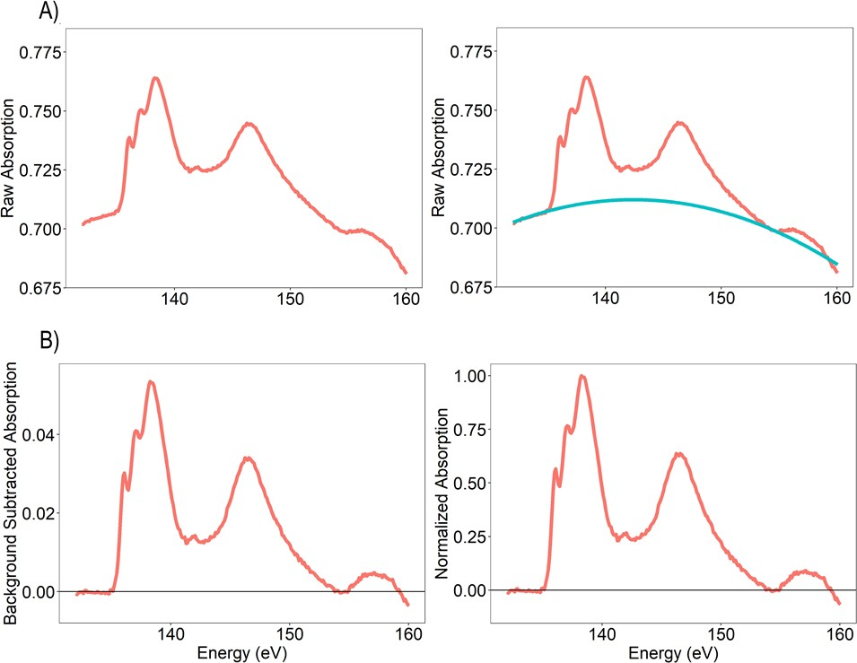FIGURES
2. **Figure 1.** (A) Background subtraction performed on a P L2,3-edge XANES spectrum of adenosine
3. triphosphate diluted with quartz to a P concentration of 40 mg g-1 (red) by fitting a grade-two
4. polynomial function(blue) between two points in the pre-edge and two points in the post edge, and
5. (B) subsequent spectrum normalization using the highest intensity point of the resulting spectrum.
6. 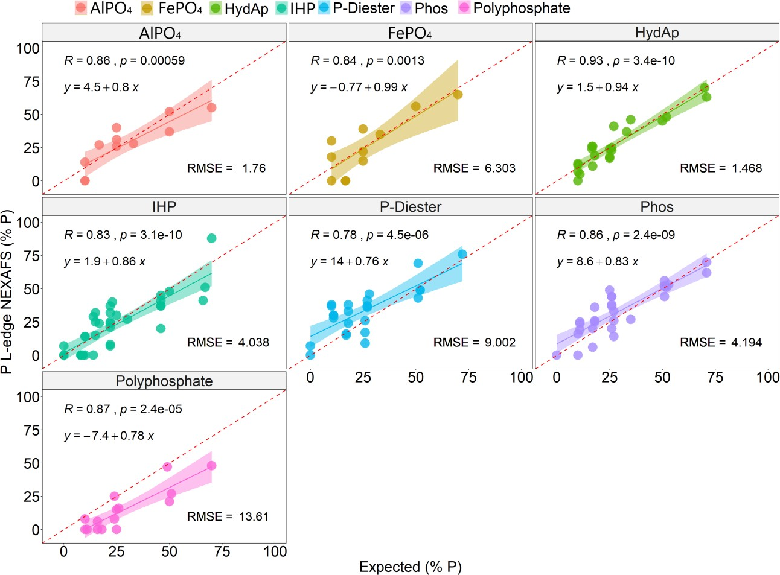
7. **Figure 2.** Comparison of the contribution of different inorganic and organic P compounds in
8. defined diluted (40 mg P g-1) ternary and quaternary standard mixtures as determined by P L2,3-
9. edge XANES spectroscopy with the true contribution of the respective compounds. Shown are
10. linear regressions, with the shadowed area representing the 95% confidence interval. Pearson’s
11. correlation coefficients (R), *p*-values and linear regression equations are printed in the upper left
12. corner of each panel, root-mean-square error (RMSE) is printed in the lower right corner of each
13. panel.

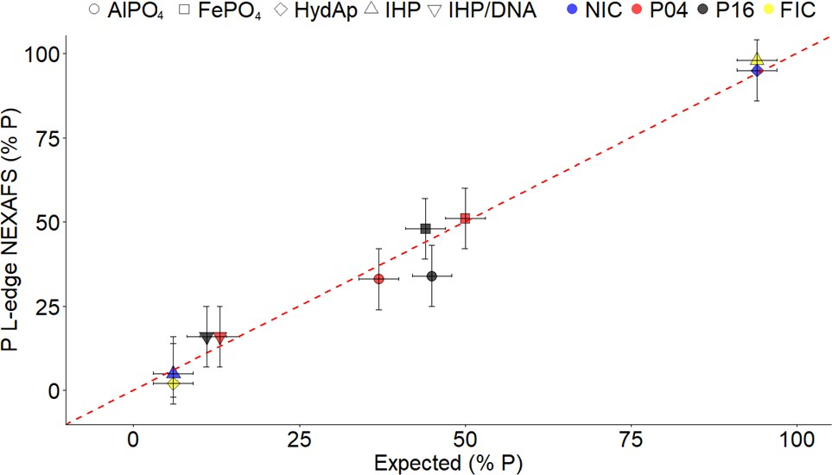**Figure 3.** Contribution of different P species in two soils (empty symbols) and two agro-industrial

1. by-products (filled symbols) as determined by deconvolution of P L2,3-edge XANES spectra using
2. the protocol presented in the current paper with the contribution of the respective P species as
3. determined by deconvolution of P K-edge XANES spectra according to Werner & Prietzel33 (soils)
4. and by 31P-NMR spectroscopy (agro-industrial by-products) conducted by Negassa et al.18 325

326

327

328

329

330

1. ASSOCIATED CONTENT
2. **Supporting Information**. Tables containing the chemical characteristics of the standards (S1),
3. results of the LC fitting exercises for the standard mixtures (S2, S3, S4), elemental composition
4. of the soil (S5) and agro-industry byproducts (S6). Comparison between quartz and phytic acid
5. with quartz spectrum (Fig. S1). Reference spectra can be freely downloaded at:
6. <https://boku.wzw.tum.de/index.php?id=458>.
7. AUTHOR INFORMATION
8. Corresponding Author

339 * Phone: +49 8161 71 - 5266; fax: +49 8161 71 - 4466; e-mail: [luis.colocho@wzw.tum.de](mailto:luis.colocho@wzw.tum.de)

1. Author Contributions
2. The manuscript was written through contributions of all authors. All authors have given approval
3. to the final version of the manuscript.
4. Funding Sources
5. L.C.C.H. and J.P. receive funding from the German Research Foundation - DFG within the
6. framework of Priority Program SPP 1685 “Ecosystem Nutrition: Forest Strategies for Limited

Phosphorus Resources” by the German Research Foundation (DFG; grant Pr 534/6-2).

1. ACKNOWLEDGMENT
2. This research used resources of the Brazilian Synchrotron Light Laboratory (LNLS), an open
3. national facility operated by the Brazilian Centre for Research in Energy and Materials (CNPEM)
4. for the Brazilian Ministry for Science, Technology, Innovations and Communications (MCTIC).
5. The PGM beamline staff is acknowledged for the assistance during the experiments. We thank
6. Carsten W. Mueller and Luis Almeida for the access of the two Antarctica samples. We also
7. acknowledge Ms. Sigrid Hiesch and Ms. Monika Weber for ICP-OES measurements.
8. REFERENCES
9. (1) Elser, J. J.; Bracken, M. E. S.; Cleland, E. E.; Gruner, D. S.; Harpole, W. S.; Hillebrand, H.;
10. Ngai, J. T.; Seabloom, E. W.; Shurin, J. B.; Smith, J. E. Global Analysis of Nitrogen and
11. Phosphorus Limitation of Primary Producers in Freshwater, Marine and Terrestrial

359 Ecosystems. *Ecol. Lett.* **2007**, *10* (12), 1135–1142.

360 (2) Walker, T. W.; Syers, J. K. The Fate of Phosphorus during Pedogenesis. *Geoderma* **1976**,

361 *15* (1), 1–19.

362 (3) Smeck, N. E. Phosphorus Dynamics in Soils and Landscapes. *Geoderma* **1985**, *36* (3–4),

363 185–199.

1. (4) Lang, F.; Bauhus, J.; Frossard, E.; George, E.; Kaiser, K.; Kaupenjohann, M.; Krüger, J.;
2. Matzner, E.; Polle, A.; Prietzel, J.; Rennenberg, H.; Wellbrock, N.. Phosphorus in Forest
3. Ecosystems: New Insights from an Ecosystem Nutrition Perspective. *J. Plant Nutr. Soil Sci.*

367 **2016**, *179* (2), 129–135.

368 (5) Turner, B. L. Resource Partitioning for Soil Phosphorus: A Hypothesis. *J. Ecol.* **2008**, *96*

369 (4), 698–702.

1. (6) Turner, B. L. Soil Organic Phosphorus in Tropical Forests: An Assessment of the NaOH-
2. EDTA Extraction Procedure for Quantitative Analysis by Solution 31P NMR Spectroscopy.

372 *Eur. J. Soil Sci.* **2008**, *59* (3), 453–466.

1. (7) Vincent, A. G.; Vestergren, J.; Gröbner, G.; Persson, P.; Schleucher, J.; Giesler, R. Soil
2. Organic Phosphorus Transformations in a Boreal Forest Chronosequence. *Plant Soil* **2013**,

375 *367* (1–2), 149–162.

1. (8) Yan, Y.; Li, W.; Yang, J.; Zheng, A.; Liu, F.; Feng, X.; Sparks, D. L. Mechanism of Myo-
2. Inositol Hexakisphosphate Sorption on Amorphous Aluminum Hydroxide: Spectroscopic
3. Evidence for Rapid Surface Precipitation. *Environ. Sci. Technol.* **2014**, *48* (12), 6735–6742.
4. (9) Wan, B.; Yan, Y.; Liu, F.; Tan, W.; Chen, X.; Feng, X. Surface Adsorption and Precipitation
5. of Inositol Hexakisphosphate on Calcite: A Comparison with Orthophosphate. *Chem. Geol.*

381 **2016**, *421*, 103–111.

1. (10) Jiang, X.; Bol, R.; Cade-Menun, B. J.; Nischwitz, V.; Willbold, S.; Bauke, S.; Vereecken,
2. H.; Amelung, W.; Klumpp, E. Colloid-Bound and Dissolved Phosphorus Species in Topsoil
3. Water Extracts along a Grassland Transect from Cambisol to Stagnosol. *Biogeosciences*

385 **2017**, *14* (5), 1153–1164.

1. (11) von Wandruszka, R. Phosphorus Retention in Calcareous Soils and the Effect of Organic
2. Matter on Its Mobility. *Geochem. Trans.* **2006**, *7*, 1–8.
3. (12) McLaren, T. I.; Smernik, R. J.; McLaughlin, M. J.; McBeath, T. M.; Kirby, J. K.; Simpson,
4. R. J.; Guppy, C. N.; Doolette, A. L.; Richardson, A. E. Complex Forms of Soil Organic
5. Phosphorus-A Major Component of Soil Phosphorus. *Environ. Sci. Technol.* **2015**, *49* (22),

391 13238–13245.

1. (13) Vestergren, J.; Vincent, A. G.; Jansson, M.; Persson, P.; Ilstedt, U.; Gröbner, G.; Giesler,
2. R.; Schleucher, J. High-Resolution Characterization of Organic Phosphorus in Soil Extracts
3. Using 2D 1H-31P NMR Correlation Spectroscopy. *Environ. Sci. Technol.* **2012**, *46* (7),

395 3950–3956.

1. (14) Wang, L.; Amelung, W.; Willbold, S. Diffusion-Ordered Nuclear Magnetic Resonance
2. Spectroscopy (DOSY-NMR): A Novel Tool for Identification of Phosphorus Compounds
3. in Soil Extracts. *Environ. Sci. Technol.* **2017**, *51* (22), 13256–13264.
4. (15) Cade-Menun, B.; Liu, C. W. Solution Phosphorus-31 Nuclear Magnetic Resonance
5. Spectroscopy of Soils from 2005 to 2013: A Review of Sample Preparation and
6. Experimental Parameters. *Soil Sci. Soc. Am. J.* **2013**, *78* (1), 19.
7. (16) Hesterberg, D. *Macroscale Chemical Properties and X-Ray Absorption Spectroscopy of*
8. *Soil Phosphorus*; Elsevier Masson SAS, 2010; Vol. 34.
9. (17) Hesterberg, D.; Zhou, W.; Hutchison, K. J.; Beauchemin, S.; Sayers, D. E. XAFS Study of
10. Adsorbed and Mineral Forms of Phosphate. *J. Synchrotron Radiat.* **1999**, *6* (3), 636–638.
11. (18) Kruse, J.; Leinweber, P. Phosphorus in Sequentially Extracted Fen Peat Soils: A K-Edge
12. X-Ray Absorption near-Edge Structure (XANES) Spectroscopy Study. *J. Plant Nutr. Soil*

408 *Sci.* **2008**, *171* (4), 613–620.

1. (19) Negassa, W.; Kruse, J.; Michalik, D.; Appathurai, N.; Zuin, L.; Leinweber, P. Phosphorus
2. Speciation in Agro-Industrial Byproduct: Sequential Fractionation, Solution XANES
3. Spectroscopy. *Environ. Sci. Technol.* **2010**, *44* (6), 2092–2097.
4. (20) Prietzel, J.; Klysubun, W.; Werner, F. Speciation of Phosphorus in Temperate Zone Forest
5. Soils as Assessed by Combined Wet-Chemical Fractionation and XANES Spectroscopy. *J.*

414 *Plant Nutr. Soil Sci.* **2016**, *179* (2), 168–185.

415 (21) Rivard, C.; Lanson, B.; Cotte, M. Phosphorus Speciation and Micro-Scale Spatial

416 Distribution in North-American Temperate Agricultural Soils from Micro X-Ray

417 Fluorescence and X-Ray Absorption near-Edge Spectroscopy. *Plant Soil* **2016**, *401* (1–2),

418 7–22.

419 (22) Hesterberg, D.; McNulty, I.; Thieme, J. Speciation of Soil Phosphorus Assessed by XANES

420 Spectroscopy at Different Spatial Scales. *J. Environ. Qual.* **2017**, *46* (6), 1190.

421 (23) Werner, F.; Mueller, C. W.; Thieme, J.; Gianoncelli, A.; Rivard, C.; Höschen, C.; Prietzel,

422 J. Micro-Scale Heterogeneity of Soil Phosphorus Depends on Soil Substrate and Depth. *Sci.*

423 *Rep.* **2017**, *7* (1), 1–9.

424 (24) Beauchemin, S.; Hesterberg, D.; Chou, J.; Beauchemin, M.; Simard, R. R.; Sayers, D. E.

425 Speciation of Phosphorus in Phosphorus-Enriched Agricultural Soils Using X-Ray

426 Absorption Near-Edge Structure Spectroscopy and Chemical Fractionation. *J. Environ.*

427 *Qual.* **2003**, *32* (5), 1809.

428 (25) Prietzel, J.; Harrington, G.; Häusler, W.; Heister, K.; Werner, F.; Klysubun, W. Reference

429 Spectra of Important Adsorbed Organic and Inorganic Phosphate Binding Forms for Soil P

430 Speciation Using Synchrotron-Based K-Edge XANES Spectroscopy. *J. Synchrotron*

431 *Radiat.* **2016**, *23* (2), 532–544.

432 (26) Kruse, J.; Leinweber, P.; Eckhardt, K. U.; Godlinski, F.; Hu, Y.; Zuin, L. Phosphorus L2,3-

433 Edge XANES: Overview of Reference Compounds. *J. Synchrotron Radiat.* **2009**, *16* (2),

434 247–259.

435 (27) Kasrai, M.; Yin, Z.; Bancroft, G. M.; Tan, K. H. X‐ray Fluorescence Measurements of X‐

436 ray Absorption near Edge Structure at the Si, P, and S *L* Edges. *J. Vac. Sci. Technol. A*

437 *Vacuum, Surfaces, Film.* **1993**, *11* (5), 2694–2699.

438 (28) Li, D.; Bancroft, G. M.; Kasrai, M.; Fleet, M. E.; Feng, X. H.; Tan, K. H. High-Resolution

439 Si and P K- and L-Edge XANES Spectra of Crystalline SiP2O7 and Amorphous SiO2-

440 P2O5. *Am. Mineral.* **1994**, *79* (DCM), 785–788.

1. (29) Yin, Z.; Kasrai, M.; Bancroft, G. M.; Tan, K. H.; Feng, X. X-Ray-Absorption Spectroscopic
2. Studies of Sodium Polyphosphate Glasses. *Phys. Rev. B* **1995**, *51* (2), 742–750.
3. (30) Kasrai, M.; Vasiga, M.; Suominen Fuller, M.; Bancroft, G. M.; Fyfe, K. Study of the Effects
4. of Ca Sulfonate on Antiwear Film Formation by X-Ray Absorption Spectroscopy Using
5. Synchrotron Radiation. *J. Synchrotron Radiat.* **1999**, *6* (3), 719–721.
6. (31) Demirkiran, H.; Hu, Y.; Zuin, L.; Appathurai, N.; Aswath, P. B. XANES Analysis of
7. Calcium and Sodium Phosphates and Silicates and Hydroxyapatite-Bioglass®45S5 Co-
8. Sintered Bioceramics. *Mater. Sci. Eng. C* **2011**, *31* (2), 134–143.
9. (32) Rajendran, J.; Gialanella, S.; Aswath, P. B. XANES Analysis of Dried and Calcined Bones.

450 *Mater. Sci. Eng. C* **2013**, *33* (7), 3968–3979.

451 (33) Rafiuddin, M. R.; Mueller, E.; Grosvenor, A. P. X-Ray Spectroscopic Study of the

452 Electronic Structure of Monazite- and Xenotime-Type Rare-Earth Phosphates. *J. Phys.*

453 *Chem. C* **2014**, *118* (31), 18000–18009.

454 (34) Rafiuddin, M. R.; Grosvenor, A. P. Probing the Effect of Radiation Damage on the Structure

455 of Rare-Earth Phosphates. *J. Alloys Compd.* **2015**, *653*, 279–289.

456 (35) Nicotra, G.; Politano, A.; Mio, A. M.; Deretzis, I.; Hu, J.; Mao, Z. Q.; Wei, J.; La Magna,

457 A.; Spinella, C. Absorption Edges of Black Phosphorus: A Comparative Analysis. *Phys.*

458 *Status Solidi Basic Res.* **2016**, *253* (12), 2509–2514.

1. (36) Susi, T.; Hardcastle, T. P.; Hofsäss, H.; Mittelberger, A.; Pennycook, T. J.; Mangler, C.;
2. Drummond-Brydson, R.; Scott, A. J.; Meyer, J. C.; Kotakoski, J. Single-Atom Spectroscopy
3. of Phosphorus Dopants Implanted into Graphene. *2D Mater.* **2017**, *4* (2).
4. (37) Donato, G.; Holzscherer, D.; Beam, J. C.; Grosvenor, A. P. A One-Step Synthesis of Rare-
5. Earth Phosphate-Borosilicate Glass Composites. *RSC Adv.* **2018**, *8* (68), 39053–39065.
6. (38) Rafiuddin, M. R.; Grosvenor, A. P. An Investigation of the Chemical Durability of Hydrous
7. and Anhydrous Rare-Earth Phosphates. *J. Nucl. Mater.* **2018**, *509*, 631–643.
8. (39) Schefe, C. R.; Kappen, P.; Zuin, L.; Pigram, P. J.; Christensen, C. Addition of Carboxylic
9. Acids Modifies Phosphate Sorption on Soil and Boehmite Surfaces: A Solution Chemistry
10. and XANES Spectroscopy Study. *J. Colloid Interface Sci.* **2009**, *330* (1), 51–59.
11. (40) Kruse, J.; Abraham, M.; Amelung, W.; Baum, C.; Bol, R.; Kühn, O.; Lewandowski, H.;
12. Niederberger, J.; Oelmann, Y.; Rüger, C.; Santner, J.; Siebers, M.; Siebers, N.; Spohn, M.;
13. Vestergren, J.; Vogts, A.; Leinweber, P. Innovative Methods in Soil Phosphorus Research:
14. A Review. *J. Plant Nutr. Soil Sci.* **2015**, *178* (1), 43–88.
15. (41) Liu, J.; Yang, J.; Cade-Menun, B. J.; Liang, X.; Hu, Y.; Liu, C. W.; Zhao, Y.; Li, L.; Shi, J.
16. Complementary Phosphorus Speciation in Agricultural Soils by Sequential Fractionation,
17. Solution P Nuclear Magnetic Resonance, and Phosphorus K-Edge X-Ray Absorption Near-
18. Edge Structure Spectroscopy. *J. Environ. Qual.* **2013**, *42* (6), 1763.
19. (42) Liu, J.; Hu, Y.; Yang, J.; Abdi, D.; Cade-Menun, B. J. Investigation of Soil Legacy
20. Phosphorus Transformation in Long-Term Agricultural Fields Using Sequential
21. Fractionation, P K-Edge XANES and Solution P NMR Spectroscopy. *Environ. Sci.*

480 *Technol.* **2015**, *49* (1), 168–176.

1. (43) Vogel, C.; Rivard, C.; Wilken, V.; Muskolus, A.; Adam, C. Performance of Secondary P-
2. Fertilizers in Pot Experiments Analyzed by Phosphorus X-Ray Absorption near-Edge
3. Structure (XANES) Spectroscopy. *Ambio* **2018**, *47* (s1), 62–72.
4. (44) Golnak, R.; Xiao, J.; Atak, K.; Unger, I.; Seidel, R.; Winter, B.; Aziz, E. F. Undistorted X-
5. Ray Absorption Spectroscopy Using s-Core-Orbital Emissions. *J. Phys. Chem. A* **2016**, *120*

486 (18), 2808–2814.

487 (45) Waki, I.; Hirai, Y. The Silicon L-Edge Photoabsorption Spectrum of Silicon Carbide. *J.*

488 *Phys. Condens. Matter* **1989**, *1* (37), 6755–6762.

489 (46) Li, D.; Bancroft, G. M.; Kasrai, M.; Fleet, M. E.; Feng, X. H.; Tan, K. H. High-Resolution

490 Si and P K- and L-Edge XANES Spectra of Crystalline SiP2O7 and Amorphous SiO2-

491 P2O5. *Am. Mineral.* **1994**, *79* (DCM), 785–788.

1. (47) Chen, J. G. NEXAFS Investigations of Transition Metal Oxides, Nitrides, Carbides,
2. Sulfides and Other Interstitial Compounds. *Surf. Sci. Rep.* **1997**, *30* (1–3), 1–152.
3. (48) Cezar, J. C.; Fonseca, P. T.; Rodrigues, G. L. M. P.; De Castro, A. R. B.; Neuenschwander,
4. R. T.; Rodrigues, F.; Meyer, B. C.; Ribeiro, L. F. S.; Moreira, A. F. A. G.; Piton, J. R.; et
5. al. The U11 PGM Beam Line at the Brazilian National Synchrotron Light Laboratory. *J.*
6. *Phys. Conf. Ser.* **2013**, *425* (PART 7).
7. (49) Ravel, B.; Newville, M. ATHENA, ARTEMIS, HEPHAESTUS: Data Analysis for X-Ray
8. Absorption Spectroscopy Using IFEFFIT. *J. Synchrotron Radiat.* **2005**, *12* (4), 537–541.
9. (50) Werner, F.; Prietzel, J. Standard Protocol and Quality Assessment of Soil Phosphorus
10. Speciation by P K -Edge XANES Spectroscopy. *Environ. Sci. Technol.* **2015**, *49* (17),

502 10521–10528.

503 (51) Hanhan, S.; Smith, A. M.; Obst, M.; Hitchcock, A. P. Optimization of Analysis of Soft X-

504 Ray Spectromicroscopy at the Ca 2p Edge. *J. Electron Spectros. Relat. Phenomena* **2009**,

505 *173* (1), 44–49.

506 (52) Negassa, W.; Kruse, J.; Michalik, D.; Appathurai, N.; Zuin, L.; Leinweber, P. Phosphorus

507 Speciation in Agro-Industrial Byproducts: Sequential Fractionation, Solution 31 P NMR,

508 and P K - and L 2,3 -Edge XANES Spectroscopy. *Environ. Sci. Technol.* **2010**, *44* (6),

509 2092–2097.

1. (53) Colocho Hurtarte, L. C.; Souza-filho, L. F.; Santos, W. O.; Vergütz, L.; Prietzel, J.;
2. Hesterberg, D. Optimization of Data Processing Minimizes Impact of Self-Absorption on
3. Phosphorus Speciation Results by P K-Edge XANES. *Soil Syst.* **2019**, *3* (3), 61.
4. (54) Weyers, E.; Strawn, D. G.; Peak, D.; Baker, L. L. Inhibition of Phosphorus Sorption on
5. Calcite by Dairy Manure-Sourced DOC. *Chemosphere* **2017**, *184*, 99–105.
6. (55) Cosmidis, J.; Benzerara, K.; Nassif, N.; Tyliszczak, T.; Bourdelle, F. Characterization of
7. Ca-Phosphate Biological Materials by Scanning Transmission X-Ray Microscopy (STXM)
8. at the Ca L2,3-, P L2,3- And C K-Edges. *Acta Biomater.* **2015**, *12* (1), 260–269.
9. (56) Wang, Y. Y.; Ho, R.; Shao, Z.; Somlyo, A. P. Optimization of Quantitative Electron Energy
10. Loss Spectroscopy in the Low Loss Region: Phosphorus L-Edge. *Ultramicroscopy* **1992**,

520 *41* (1–3), 11–31.

521 (57) Klysubun, W.; Sombunchoo, P.; Deenan, W.; Kongmark, C. Performance and Status of

522 Beamline BL8 at SLRI for X-Ray Absorption Spectroscopy. *J. Synchrotron Radiat.* **2012**,

523 *19* (6), 930–936.

1. (58) Klysubun, W.; Tarawarakarn, P.; Thamsanong, N.; Amonpattaratkit, P.; Cholsuk, C.;
2. Lapboonrueng, S.; Chaichuay, S.; Wongtepa, W. Upgrade of SLRI BL8 Beamline for
3. XAFS Spectroscopy in a Photon Energy Range of 1–13 keV. *Radiat. Phys. Chem.* **2019**.
4. (59) Prietzel, J.; Prater, I.; Colocho Hurtarte, L. C.; Hrbáček, F.; Klysubun, W.; Mueller, C. W.
5. Site Conditions and Vegetation Determine Phosphorus and Sulfur Speciation in Soils of
6. Antarctica. *Geochim. Cosmochim. Acta* **2019**, *246*, 339–362.
7. (60) Kruse, J.; Negassa, W.; Appathurai, N.; Zuin, L.; Leinweber, P. Phosphorus Speciation in
8. Sequentially Extracted Agro-Industrial By-Products: Evidence from X-Ray Absorption
9. Near Edge Structure Spectroscopy. *J. Environ. Qual.* **2010**, *39* (6), 2179.
10. (61) Tatur, A.; Barczuk, A. Ornithogenic Phosphates on King George Island in the Maritime
11. Antarctic. In *Antarctic Nutrient Cycles and Food Webs*; Springer Berlin Heidelberg: Berlin,

535 Heidelberg, 1985; pp 163–168.

1. (62) Tatur, A. Ornithogenic Ecosystems in the Maritime Antarctic — Formation, Development
2. and Disintegration; 2002; pp 161–184.
3. (63) Otero, X. L.; Tejada, O.; Martín-Pastor, M.; De La Peña, S.; Ferreira, T. O.; Pérez-Alberti,
4. A. Phosphorus in Seagull Colonies and the Effect on the Habitats. The Case of Yellow-
5. Legged Gulls (Larus Michahellis) in the Atlantic Islands National Park (Galicia-NW Spain).

541 *Sci. Total Environ.* **2015**, *532*, 383–397.

542 (64) Doolette, A. L.; Smernik, R. J.; Dougherty, W. J. Overestimation of the Importance of

543 Phytate in NaOH-EDTA Soil Extracts as Assessed by 31P NMR Analyses. *Org. Geochem.*

544 **2011**, *42* (8), 955–964.

1. (65) Vogel, C.; Adam, C.; Sekine, R.; Schiller, T.; Lipie, E.; McNaughton, D. Determination of
2. Phosphorus Fertilizer Soil Reactions by Raman and Synchrotron Infrared
3. Microspectroscopy. *Appl. Spectrosc.* **2013**, *67* (10), 1165–1170.
4. (66) Beauchemin, S.; Hesterberg, D.; Beauchemin, M. Principal Component Analysis Approach
5. for Modeling Sulfur K-XANES Spectra of Humic Acids. *Soil Sci Soc Am J* **2002**, *66*, 83–

550 91.

1. (67) Siebers, N.; Kruse, J.; Eckhardt, K. U.; Hu, Y.; Leinweber, P. Solid-Phase Cadmium
2. Speciation in Soil Using L 3-Edge XANES Spectroscopy with Partial Least-Squares
3. Regression. *J. Synchrotron Radiat.* **2012**, *19* (4), 579–585.
4. (68) Siebers, N.; Kruse, J.; Leinweber, P. Speciation of Phosphorus and Cadmium in a
5. Contaminated Soil Amended with Bone Char: Sequential Fractionations and XANES
6. Spectroscopy. *Water. Air. Soil Pollut.* **2013**, *224* (5).
7. (69) Vogel, C.; Sekine, R.; Steckenmesser, D.; Lombi, E.; Herzel, H.; Zuin, L.; Wang, D.; Félix,
8. R.; Adam, C. Combining Diffusive Gradients in Thin Films (DGT) and Spectroscopic
9. Techniques for the Determination of Phosphorus Species in Soils. *Anal. Chim. Acta* **2019**,

560 *1057*, 80–87.

561 (70) Benzerara, K.; Yoon, T. H.; Tyliszczak, T.; Constantz, B.; Spormann, A. M.; Brown, G. E.

562 Scanning Transmission X-Ray Microscopy Study of Microbial Calcification. *Geobiology*

563 **2004**, *2* (4), 249–259.

564 (71) Liu, L.; Milas, N.; Mukai, A. H. C.; Resende, X. R.; De Sá, F. H. The Sirius Project. *J.*

565 *Synchrotron Radiat.* **2014**, *21* (5), 904–911.

566 (72) Tavares, P. F.; Leemann, S. C.; Sjöström, M.; Andersson, Å. The Max Iv Storage Ring

567 Project. *J. Synchrotron Radiat.* **2014**, *21* (5), 862–877.

568 (73) Raimondi, P. ESRF-EBS: The Extremely Brilliant Source Project. *Synchrotron Radiat.*

569 *News* **2016**, *29* (6), 8–15.

1. (74) Schroer, C. G.; Agapov, I.; Brefeld, W.; Brinkmann, R.; Chae, Y. C.; Chao, H. C.; Eriksson,
2. M.; Keil, J.; Nuel Gavaldà, X.; Röhlsberger, R.; et al. PETRA IV: The Ultralow-Emittance
3. Source Project at DESY. *J. Synchrotron Radiat.* **2018**, *25* (5), 1277–1290.
4. (75) Georgiou, R.; Gueriau, P.; Sahle, C. J.; Bernard, S.; Mirone, A.; Garrouste, R.; Bergmann,
5. U.; Rueff, J. P.; Bertrand, L. Carbon Speciation in Organic Fossils Using 2D to 3D X-Ray
6. Raman Multispectral Imaging. *Sci. Adv.* **2019**, *5* (8), 1–10.
7. (76) Doriese, W. B.; Abbamonte, P.; Alpert, B. K.; Bennett, D. A.; Denison, E. V.; Fang, Y.;
8. Fischer, D. A.; Fitzgerald, C. P.; Fowler, J. W.; Gard, J. D.; et al. A Practical
9. Superconducting-Microcalorimeter X-Ray Spectrometer for Beamline and Laboratory
10. Science. *Rev. Sci. Instrum.* **2017**, *88* (5).